Luca FABRIS, MD, PhD

Adjunct Assistant Professor of Internal Medicine (Digestive Diseases)
Associate Professor of Gastroenterology, Department of Molecular Medicine, University of Padova

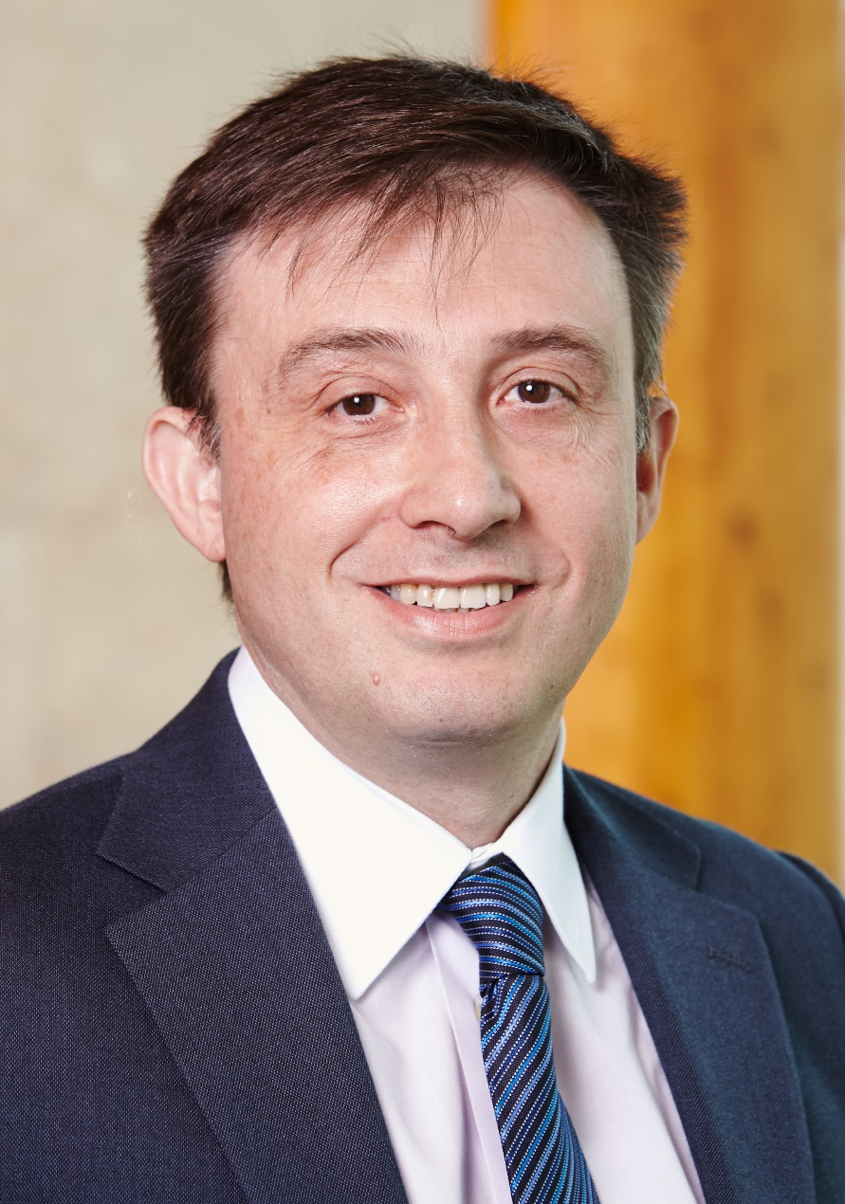

BIOGRAPHY
DEPARTMENTS AND ORGANIZATIONS
Internal Medicine: Digestive Diseases | Liver Center
Faculty Research

EDUCATION & TRAINING
PhD | University of Milan, Italy (1997)
MD | University of Padova, Italy (1987)
Resident | University of Padova, Italy
Fellow | University of Padova, Italy
Fellow | University of Birmingham, United Kingdom (1995-96)

RESEARCH & PUBLICATIONS

Research Interests
Biliary Tract Diseases; Cholangiocarcinoma; Congenital Hepatic Fibrosis; Primary Sclerosing Cholangitis

Research Organizations
Internal Medicine: Digestive Diseases | Liver Center
Faculty Research

Research Summary
The major goal of my research is to study the cell biology of biliary epithelial cells and apply this knowledge to understand the pathophysiology of biliary tree diseases (cholangiopathies). This goal is pursued within two specific areas of interest:
- Genetic and immune-mediated cholangiopathies, as models of liver disease to study:
- liver repair mechanisms, with focus on the role of ductular reaction as it relates to the progression of chronic biliary damage
- epithelial-mesenchymal interactions and cross-talk mechanisms, with focus on the involvement of macrophages and fibrocytes in liver fibrosis

- Cholangiocarcinoma, with main focus on mechanisms of cancer invasiveness, by unravelling:
- tumor-stroma interactions and pro-invasive role of tumor reactive stroma
- characterization of tumor biomarkers of enhanced invasive phenotype as tool for molecularly targeted therapies

My scientific and professional interests extend to: 1) clinical management of rare liver diseases, 2) definition and application of outcome indicators (value-based medicine in hepatology) in immune-related liver diseases (AIH, PBC, PSC).

Selected Publications
- Cadamuro M, Spagnuolo G, Sambado L, Indraccolo S, Nardo G, Rosato A, Brivio S, Caslini C, Stecca T, Massani M, Bassi N, Novelli E, Spirli C, Fabris L, Strazzabosco M. Low dose paclitaxel reduces S100A4 nuclear import to inhibit invasion and hematogenous metastasis of cholangiocarcinoma. Cancer Res 2016; 76:4775-84.
- Locatelli L, Cadamuro M, Spirli C, Fiorotto R, Lecchi S, Morell CM, Popov Y, Scirpo R, De Matteis M, Amenduni M, Pietrobattista A, Torre G, Schuppan D, Fabris L, Strazzabosco M. Macrophage recruitment by Fibrocystin-defective biliary epithelial cells promotes portal fibrosis in Congenital Hepatic Fibrosis. Hepatology 2016; 63:965-82.
- Morton SD, Cadamuro M, Brivio S, Vismara M, Stecca T, Massani M, Bassi N, Furlanetto A, Joplin RE, Floreani A, Fabris L, Strazzabosco M. Leukemia inhibitory factor protects cholangiocarcinoma cells from drug-induced apoptosis via a PI3K/AKT-dependent Mcl-1 activation. Oncotarget 2015; 6:26052-64.
- Cadamuro M, Nardo G, Indraccolo S, Dall'olmo L, Sambado L, Moserle L, Franceschet I, Colledan M, Massani M, Stecca T, Bassi N, Morton S, Spirli C, Fiorotto R, Fabris L, Strazzabosco M. Platelet-derived growth factor-D and Rho GTPases regulate recruitment of cancer-associated fibroblasts in cholangiocarcinoma. Hepatology 2013; 58: 1042-53.
- Strazzabosco M, Fabris L. Development of the bile ducts: essentials for the clinical hepatologist. J Hepatol 2012; 56:1159-70.
- Fabris L, Cadamuro M, Moserle L, Dziura J, Cong X, Sambado L, Nardo G, Sonzogni A, Colledan M, Furlanetto A, Bassi N, Massani M, Cillo U, Mescoli C, Indraccolo S, Rugge M, Okolicsanyi L, Strazzabosco M. Nuclear expression of S100A4 calcium binding protein increases cholangiocarcinoma invasiveness and metastatisation. Hepatology 2011; 54:890-9.
- Fabris L, Strazzabosco M. Epithelial-mesenchymal interactions in biliary diseases. Semin Liver Dis 2011; 31:11-32.
- Fabris L, Cadamuro M, Libbrecht L, Raynaud P, Spirlì C, Fiorotto R, Okolicsanyi L, Lemaigre F, Strazzabosco M, Roskams T. Epithelial expression of angiogenic growth factors modulate arterial vasculogenesis in human liver development. Hepatology 2008; 47:719-28.
- Fabris L, Cadamuro M, Guido M, Spirlì C, Fiorotto R, Colledan M, Torre G, Alberti D, Sonzogni A, Okolicsanyi L, Strazzabosco M. Analysis of liver repair mechanisms in Alagille Syndrome and Biliary Atresia reveals a role for Notch signaling. Am J Pathol 2007; 171:641-53.
- Fabris L, Cadamuro M, Fiorotto R, Roskams T, Spirlì C, Melero S, Sonzogni A, Joplin RE, Okolicsanyi L, Strazzabosco M. Effects of angiogenic factor overexpression by cholangiocytes in polycystic liver diseases. Hepatology 2006; 43:1001-12.
- Spirli C, Fabris L, Duner E, Fiorotto R, Ballardini G, Roskams T, Larusso NF, Sonzogni A, Okolicsanyi L, Strazzabosco M. Cytokine-stimulated nitric oxide production inhibits adenylyl cyclase and cAMP-dependent secretion in cholangiocytes. Gastroenterology 2003; 124:737-53.
- Fabris L, Strazzabosco M, Crosby HA, Ballardini G, Hubscher SG, Kelly DA, Neuberger JM, Strain AJ, Joplin R. Characterization and isolation of ductular cells coexpressing neural cell adhesion molecule and Bcl-2 from primary cholangiopathies and ductal plate malformations. Am J Pathol 2000; 156:1599-612.

