CLINICAL EMBRYOLOGIST
Olga Chaplia, PhD  Age: 34  Place of birth: Kyiv, Ukraine  Nationality: Ukrainian | 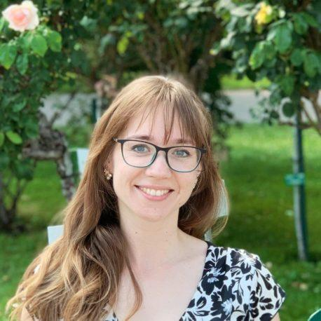
 | E-mail: olga.chaplia@gmail.com
 | Phone: +38-097-796-69-95
Employment history
March 2019 – now | IVMED clinic LLC (Kyiv, Ukraine)  Senior Embryologist
October 2020 – now | OVOGENE Egg Bank (Kyiv, Ukraine)  Senior Embryologist, Scientific Consultant
June 2013 – March 2019 | “Reproductive Genetics Clinic “Victoria” LLC (Kyiv, Ukraine)  Senior Embryologist
November 2010 – June 2013 | “Reproductive Genetics Institute” LLC (Kyiv, Ukraine)  Cytogeneticist
Education
2015 | PhD degree in Cytology, Histology and Molecular Biology  PhD thesis: “Preimplantation in vitro development of human embryos possessing numerical chromosome abnormalities”
2010 − 2013 | Fellowship, Centre of Molecular and Cell Research, National University of Kyiv-Mohyla Academy (Kyiv, Ukraine)
2004 – 2010 | Master degree in Biology, National University of Kyiv-Mohyla Academy (Kyiv, Ukraine)
2004 – 2008 | Bachelor degree in Biology, National University of Kyiv-Mohyla Academy (Kyiv, Ukraine)
Achievements and grades
2019 | ESHRE Certification as Senior Embryologist
2018 | Finalist of a biomedical start-up contest “MBioS Challenge” with a project dedicated to CRISPR-Cas9 gene editing tool (Kyiv, Ukraine)
2017 | Official vitrification workshop on Cryotech method (Kyiv, Ukraine)
2017 | Hands-on training “Biopsy and PGD-24” at “Institut Marquez” (Barcelona, Spain)
2016 | Hands-on training course “Oocytes vitrification” at “Genera” (Rome, Italy)

Professional Skills
- Clinical embryology: dish preparation; sperm analysis, washing, and freezing; egg collection and denudation; conventional IVF, ICSI; embryo grading; oocyte and embryo vitrification and thawing; embryo transfer; blastomere and trophectoderm biopsy, tubing of biopsied cells for molecular testing; testicular and epididymal samples preparation. Counselling of patients including PGT-cases. Laboratory quality control management. Laboratory audit (Ukraine, Cambodia, Thailand).
- Cytogenetics: culture of prenatal and postnatal samples, preparation of chromosome smears, GTG-banding, analysis of karyotype; fluorescent in situ hybridization, fixation and analysis of trophectoderm samples.
- Conference participation as speaker and abstracts author.

Language skills: Ukrainian (native), Russian (fluent), English (fluent).
Interests and hobbies: yoga, dancing, popularization of science, violets.

